**Objective**

Retro Stores wants to create an annual sales report for 2022. So that, Retro Stores can understand their customers and grow more sales in 2023.

**Questions**

* Compare the sales and orders using single chart
* Which month got the highest sales and orders?
* Who purchased more- men or women in 2022?
* What is the different order status in 2022?
* List of top 10 states contributing to the sales?
* Relation between age and gender based on sales amount?
* Which channel is contributing to maximum sales?
* Highest selling category? etc.

**Retro Stores Annual Report-2022 Dashboard**

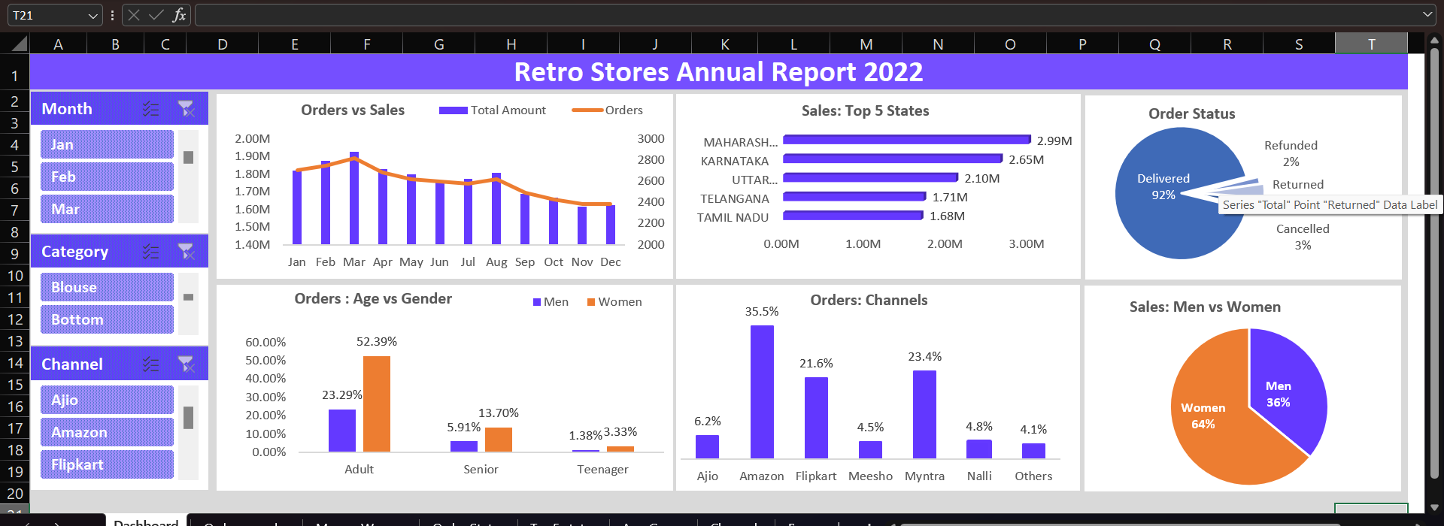

**Sample Insights**

* Women are more likely to buy compared to men (~64%)
* Maharashtra, Uttar Pradesh and Karnataka are the top 3 states
* Adult age group (20-49 yrs.) is maximum contributing (~75%)
* Amazon, Flipkart and Myntra channels are max contributing (~80%)

**Final Conclusion to improve Retro Soul sales:**

* Target women customers of age group (20-49 yrs.) who lives in Maharashtra, Karnataka and Uttar Pradesh by short ads/offers/coupons available on Amazon, Flipkart and Myntra.